**桂林电子科技大学** **2025 年中国政府奖学金国际暑期学校招生简章**

**Guilin University of Electronic Technology 2025 Chinese**

**Government Scholarship International Summer School Brochure**

一、项目地点：桂林电子科技大学（位于广西桂林）

Project Location: Guilin University of Electronic Technology (location: Guilin, Guangxi)

桂林电子科技大学坐落于世界著名的风景游览城市和中国历史 文化名城—广西桂林市。桂林市以“ 山清、水秀、洞奇、石美 ”著称， 被誉为“大自然艺术之宫 ”。其壮丽的山水景观和丰富的历史文化吸 引了无数游客。桂林电子科技大学始建于 1960 年，是中国工业和信 息化部、国防科技工业局与广西共建高校，也是中国四所电子科技大 学之一。

Guilin University of Electronic Technology is in Guilin city, Guangxi—a world-renowned tourist destination and a historic cultural city in China. Known for its "stunning mountains, beautiful waters, mystical caves, and picturesque rocks". Guilin is celebrated as the "Palace of Nature's Art". Its magnificent natural landscapes and rich historical culture attract countless tourists. Established in 1960, Guilin University of Electronic Technology is jointly built by China’s Ministry of Industry

and Information Technology (MIIT), the National Defense Technology Industry Bureau, and the Guangxi Zhuang Autonomous Region. It is also one of the four prestigious electronic science and technology universities in China.





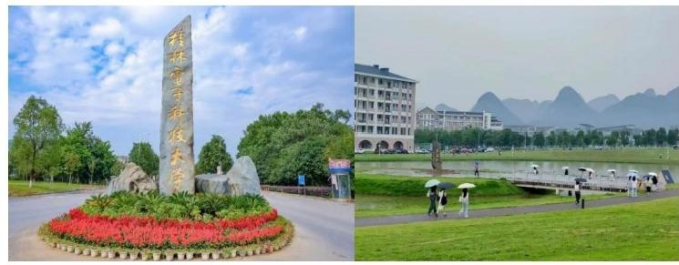

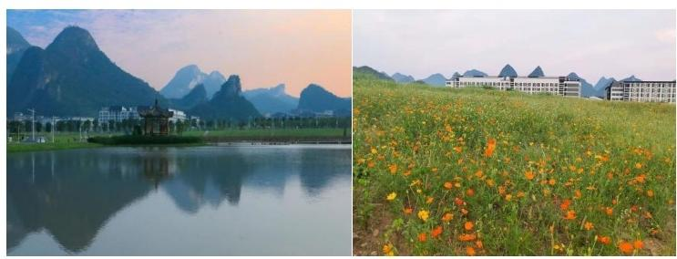

二、项目内容

Project content

（一）子项目一

Sub-project 1

1.项目名称：智造未来国际夏令营

Project Name: Smart Future International Summer Camp

2.项目时间：2025 年 6 月 28 日-7 月 22 日

Duration: June 28 - July 22, 2025

3.项目授课语言：英语

Project Teaching Language: English

4.主要生源国别： 日本、新加坡、越南及欧美国家

Main Source Countries: Japan, Singapore, Vietnam, and

Euro-American countries

5.生源层次：硕士研究生、博士研究生

Student Categories: Master's candidates and Doctoral candidates

6.项目介绍：通过智能制造 VR 实践、芯片封测实训、智能机器 人开发、智能驾驶体验、智能制造沙龙与会议、中国传统文化体验， 增强学生文化认知与实践创新能力。

Project Description: Through smart manufacturing VR practices, chip packaging and testing training, intelligent robot development, smart driving experiences, smart manufacturing salons and conferences, and

traditional Chinese cultural experiences, students' cultural awareness and practical innovation capabilities are enhanced.

（二）子项目二

Sub-project 2

1.项目名称：信息与通信前沿夏令营

Project Name: Information and Communication Frontier Summer Camp

2.项目时间：2025 年 6 月 29 日-7 月 22 日

Project Duration: June 29 - July 22, 2025

3.项目授课语言：英语

Project Teaching Language: English

4.主要生源国别： 日本、美国及其它欧美国家

Main Source Countries: Japan, United States, and other Euro-American countries

5.生源层次：本科生

Student Categories: Bachelor candidates

6.项目介绍：通过专家讲座、参观交流、实操实践、跨国团队科 研小组讨论、文化沉浸体验等活动，提升学生对新一代通信技术、新 一代信息技术、人工智能、集成电路等领域理解和兴趣，促进中外学 术文化交流。

Project Description: Through expert lectures, study visits, hands-on practice, cross-national team research discussions, and cultural immersion

activities, students' understanding and interest in next-generation communication technologies, next-generation IT, artificial intelligence, integrated circuits and other fields will be enhanced, and academic and cultural exchanges between China and foreign countries will be promoted.

（三）子项目三

Sub-project 3

1.项目名称：人工智能应用技术国际夏令营

Project Name: Artificial Intelligence Application Technologies International Summer Camp

2.项目时间：2025 年 6 月 28 日-7 月 22 日

Duration: June 28 - July 22, 2025

3.项目授课语言：英语

Project Teaching Language: English

4.主要生源国别：马来西亚、柬埔寨、老挝

Main Source Countries: Malaysia, Cambodia, and Laos

5.生源层次：本科生、硕士研究生

Student Categories: Bachelor and master’s candidates

6.项目介绍：通过开展“数字丝路 ”东盟青年学者访学计划、人 工智能基础与应用、北斗导航技术融合和学术联动、中国传统文化体 验，培育面向中国-东盟命运共同体建设的复合型人才。

Project Description: Through implementing initiatives such as the “Digital Silk Road” ASEAN Young Scholars Program, basic and applied AI training, BeiDou navigation technology integration and academic collaboration, and traditional Chinese cultural immersion, we will cultivate compound talents for the building of a China-ASEAN community with a shared future.

（四）子项目四

Sub-project 4

1.项目名称：人工智能与未来技术国际夏令营

Project Name: Artificial Intelligence and Future Technology International Summer Camp

2.项目时间：2025 年 7 月 1 日-7 月 25 日

Duration: July 1 - 25, 2025

3.项目授课语言：英语

Project Teaching Language: English

4.主要生源国别：韩国、新加坡、日本、英国、德国及其它欧美 国家

Main Source Countries: South Korea, Singapore, Japan, the UK, Germany and other Euro-American countries

5.生源层次：本科生、硕士研究生、博士研究生、研究人员

Student Categories: Bachelor’s, Master's, Doctoral candidates, and Researchers

6.项目介绍：通过邀请领域内专家分享最新研究成果和技术趋势、 围绕特定主题开展实践操作、鼓励参与者就感兴趣的话题进行深入交 流、中国传统文化与前沿科技体验，帮助国际学生及学者深入了解人 工智能领域教学、研究及其在支持未来产业发展中的作用。

Project Description: Inviting experts in the field to share the latest research results and technology trends, conducting practical operations around specific topics, encouraging participants to have in-depth exchanges on topics of interest, and experiencing traditional Chinese culture and cutting-edge science and technology, international students and scholars will be helped to understand the teaching and research of artificial intelligence (AI) and its role in supporting the development of future industries.

三、资助内容

Supported Items

学费、校内住宿费、生活费及综合医疗保险，标准参照 CSC 短期 项目执行。

Tuition fees, on-campus accommodation, living expenses, and comprehensive medical insurance will be covered according to the standards of CSC short-term programs.

四、申请相关内容

Application Details

（一）申请者身份

Application status

申请人须为境外高等院校或机构的在读本科及以上层次学生及 在职教师、青年科研人员等外籍学生、学者。

Applicants must be international students or scholars, including currently enrolled undergraduate students, in-service faculty members, and young researchers from overseas higher education institutions or organizations.

（二）申请方式

Application Method

即日起接受报名。填写 《桂林电子科技大学 2025 年中国政府奖学金国际暑期学校项目申请 表》。

Enrollment is now open. For registration, please complete the Application Form for Guilin University of Electronic Technology 2025 Chinese Government Scholarship International Summer School Program.